Instagram Analytics: Marketing & Investor Insights

Project Description
- This project analyzes an Instagram-like SQL database to provide useful insights for marketing and investor teams. It focuses on identifying loyal users, inactive users, contest winners, popular hashtags, and the best day to launch ad campaigns. It also includes key metrics such as average user engagement and detection of potential bot activity.
- The analysis is done using targeted SQL queries designed to answer specific business questions. These insights support data-driven decisions to improve marketing strategies and inform investor reports
Approach
- Requirement Analysis: Carefully reviewed each marketing and investor-related task and converted them into specific SQL objectives.
- Data Exploration: Analyzed the database structure, identified issues such as column name errors, and planned appropriate joins and aggregations.
- Query Design: Developed clean, modular SQL queries using Common Table Expressions (CTEs), handled edge cases like tied results and division errors, and ensured accurate relationships between tables.
- Performance Optimization: Suggested relevant indexes for better performance on larger datasets and wrote queries that are both efficient and easy to understand.
- Validation: Verified the output of each query using sample data to ensure accuracy and consistency.
- Hashtag Strategy: The most frequently used hashtags provide guidance for maximizing content reach and visibility.
- Optimal Timing: Analyzing user sign-up trends by weekday helps determine the best time to launch advertising campaigns.
- Engagement Metrics: Average posts per user and the photo-to-user ratio offer a clear view of overall platform activity.
- Bot Detection: Spotting users who have liked every photo supports efforts to detect and manage suspicious or automated accounts.

A) MARKETING ANALYSIS

1. Loyal User Reward: Top 5 oldest users
select id, username, created_at
from users
order by created_at asc
limit 5;
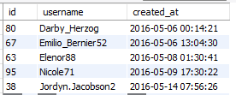

2. Inactive User Engagement: Users who never posted
select u.id , u.username
from users u
left join photos p on u.id = p.user_id
where p.id is null;
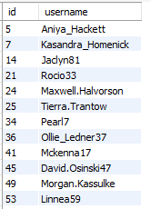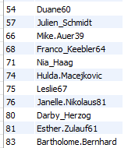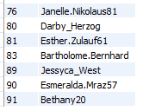

3. Contest Winner Declaration: User with most likes on a single photo
select p.id as photo_id, p.image_url, p.user_id, p.user_id, u.username, count(l.user_id)
as like_count
from photos p
join likes l on p.id = l.photo_id
join users u on p.user_id = u.id
group by p.id
order by like_count desc
limit 1;
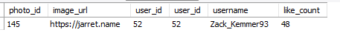

4. Hashtag Research: Top 5 most used hashtags
select t.tag_name, count(*) as usage_count
from photo_tags pt
join tags t on pt.tag_id = t.id
group by t.tag_name
order by usage_count desc
limit 5;
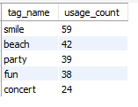
5. Ad Campaign Launch: Best day for user signups
select dayname(created_at) as day_of_week, count(*) as num_registrations
from users
group by day_of_week
order by num_registrations desc
limit 1;
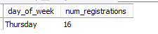

B) INVESTOR METRICS

1. User Engagement: Average posts per user, and photos/users ratio
select round(count(*)/(select count(*)
from users),2)
as avg_posts_per_user
from photos ;
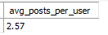

2. Bot Detection: Users who liked every photo (potential bots)
select u.id, u.username
from users u
where (
select count(*) from likes where user_id = u.id) = (select count(*) from photos);
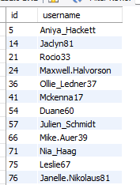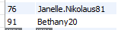

Tech Used
- MySQL 8.0: Selected for its strong support of modern SQL features such as window functions and Common Table Expressions (CTEs).
- MySQL Workbench : Used for writing, testing, and documenting SQL queries in a user-friendly environment.
Insights
- User Retention: Identifying the oldest users enables the team to reward loyalty and improve long-term engagement.
- Inactivity: Highlighting users who have never posted helps target re-engagement efforts through marketing campaigns.
- Viral Content: Contest results reveal not only the top performer but also insights into what type of content attracts the most attention.
Result
This project provided useful insights for both marketing and investor teams. The SQL analysis answered all key questions effectively, handled edge cases, and included suggestions for scaling. It also strengthened my SQL skills, improved my understanding of data quality, and showed the importance of data-driven decisions in social media. The results can help shape marketing strategies, content planning, and build investor trust in the platform's growth and reliability

